# Raspberry Pi + MAX31850

## Wiring

### One MAX31850 Thermocouple Amplifier

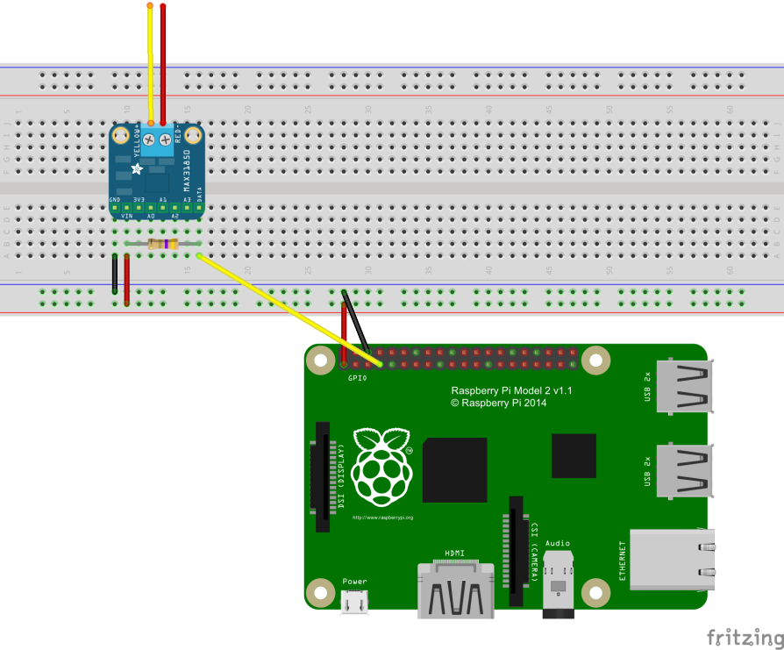

### Many MAX31850 Thermocouple Amplifiers

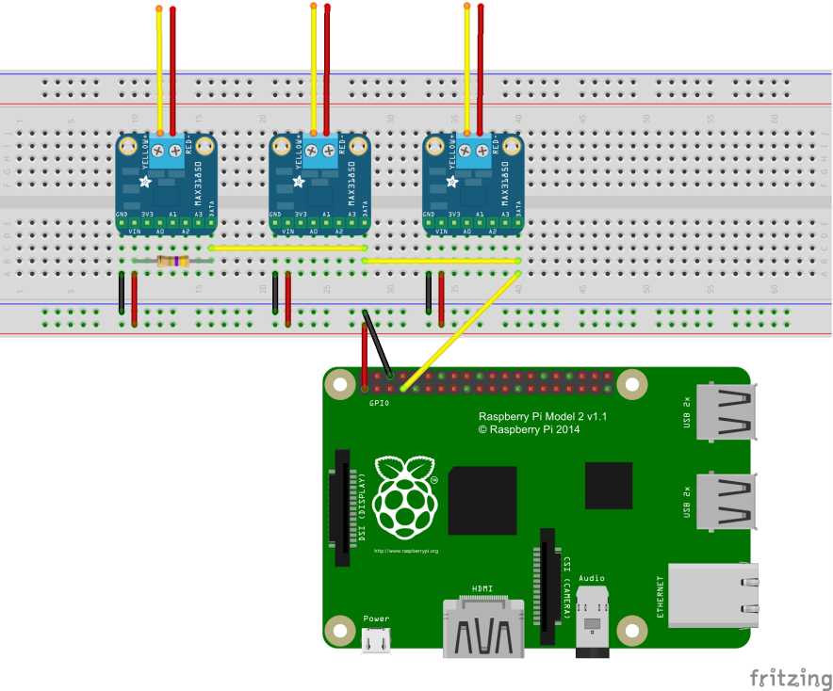

## Configure Raspberry Pi

The Raspberry Pi must be configured to support 1-Wire devices.

sudo nano /boot/config.txt

Append file with the following lines:

# Enable OneWire support

dtoverlay=w1-gpio

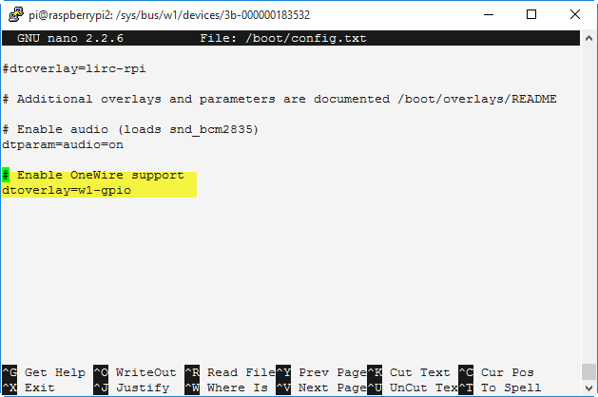

The Raspberry Pi must also be configured to load the drivers at startup.

sudo nano /etc/modules

Append file with the following lines:

w1-gpio

w1-therm

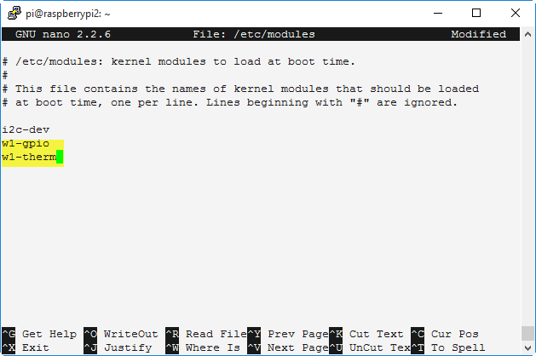

Reboot the Raspberry Pi

sudo reboot

Test that the drivers have loaded and the thermocouple amplifiers have been detected.

ls /sys/bus/w1/devices

You should see a list of your devices.



Test one of the devices

cat /sys/bus/w1/devices/3b-000000183532/w1_slave

